RAJALAKSHMI ENGINEERING COLLEGE
(An Autonomous Institution, Affiliated to Anna University, Chennai)

MINI PROJECT

QUANTITATIVE FINANCIAL MARKET &
PORTFOLIO PERFORMANCE ANALYTICS
Using Python, Power BI, and Tableau
Framework for Data Visual Analytics

SUBMITTED BY
ABRIN RITHISH G S
Roll No: 241501009

ABSTRACT
This mini project, carried out for the subject Framework for Data Visual Analytics (FDVA), demonstrates a quantitative workflow for analysing financial markets and portfolio performance using Python, Microsoft Power BI, and Tableau. The report uses an illustrative daily market dataset containing dates, ticker symbols, sectors, opening prices, daily highs and lows, closing prices, and trading volumes for five example equities. The data is generated for demonstration and is not a source of actual investment advice or verified historical market observations.
Python and Pandas are used to inspect data types, identify duplicate date–ticker records, handle missing prices and volumes, calculate daily returns, and derive 20-day and 50-day moving averages and 20-day rolling volatility. Matplotlib and Seaborn-style visual analytics are represented through eight financial charts: an OHLC candlestick-style view, moving-average trends, average daily volume, monthly portfolio returns, rolling volatility, normalized price performance, a daily-return correlation heatmap, and portfolio drawdown.
The illustrative equal-weight portfolio's calculated total return over the sample window is 12.25%, annualized volatility is 9.59%, annualized Sharpe ratio (using a zero risk-free-rate assumption) is 0.63, and maximum drawdown is -14.52%. These values are calculated from the synthetic sample included with this report and will differ from real market results. Power BI and Tableau dashboard designs are described using financial KPIs and filters such as ticker symbol, sector, and date range. The project illustrates how data preparation, quantitative metrics, and interactive dashboards can support structured portfolio monitoring.
Keywords: Financial Analytics, Daily Returns, Moving Average, Volatility, Sharpe Ratio, Maximum Drawdown, Portfolio Diversification, Power BI, Tableau.

1. Data Preprocessing Using Python
The illustrative dataset contains daily observations for five equity tickers across business days from January 2024 through December 2025. Each record includes Date, Ticker, Sector, Open, High, Low, Close, and Volume. The workflow below is designed to be reusable with a properly sourced financial CSV file. Market holidays should not be fabricated as trading observations; missing trading sessions should be checked against an exchange calendar before any filling is performed.

1.1 Loading and inspecting the data
import pandas as pd
import numpy as np
df = pd.read_csv("financial_market_data.csv")
df["Date"] = pd.to_datetime(df["Date"], errors="coerce")
print(df.shape)
print(df.info())
print(df.head())
The Date column is converted to datetime format, while price and volume fields must be numeric. A consistent Date–Ticker key allows each security's observations to be checked independently.

1.2 Missing values and duplicate observations
price_cols = ["Open", "High", "Low", "Close", "Volume"]
for col in price_cols:
df[col] = pd.to_numeric(df[col], errors="coerce")
print(df.isna().sum())
print("Duplicate Date-Ticker rows:",
df.duplicated(subset=["Date", "Ticker"]).sum())
df = df.drop_duplicates(subset=["Date", "Ticker"])
df = df.dropna(subset=["Date", "Ticker"])
df = df.sort_values(["Ticker", "Date"])
Missing values should be investigated before being treated. Duplicate Date–Ticker rows are removed after checking the source. A missing closing price can be interpolated for a classroom demonstration, but financial analysis should normally preserve missingness or obtain the correct exchange record rather than silently inventing a price. The illustrative dataset uses interpolation for isolated missing Close values and median replacement for missing Volume values.

1.3 Cleaning missing prices and volumes
df["Close"] = df.groupby("Ticker")["Close"].transform(
lambda s: s.interpolate(limit_direction="both")
)
df["Volume"] = df.groupby("Ticker")["Volume"].transform(
lambda s: s.fillna(s.median())
)
# Validate OHLC relationships
invalid_ohlc = df[
(df["High"] < df[["Open", "Close", "Low"]].max(axis=1)) |
(df["Low"] > df[["Open", "Close", "High"]].min(axis=1))
]
print("Rows requiring OHLC review:", len(invalid_ohlc))
The cleaning logic is followed by validation checks. Any adjusted or interpolated observations should be documented, since these choices can affect return calculations and risk estimates.

1.4 Handling market dates
# Inspect the date coverage separately for each ticker
coverage = df.groupby("Ticker")["Date"].agg(["min", "max", "count"])
print(coverage)
# Optional: compare each ticker with an official exchange calendar.
# Do not fill weekends or market holidays as if they were trading days.
df = df.sort_values(["Ticker", "Date"])
Financial markets operate on trading calendars rather than every calendar day. The report therefore retains observed business-date records and recommends comparing them with the relevant exchange calendar. Missing sessions should be distinguished from legitimate weekends and holidays.

1.5 Calculating returns, moving averages, and volatility
df["Daily_Return"] = df.groupby("Ticker")["Close"].pct_change()
df["MA_20"] = df.groupby("Ticker")["Close"].transform(
lambda s: s.rolling(20, min_periods=20).mean()
)
df["MA_50"] = df.groupby("Ticker")["Close"].transform(
lambda s: s.rolling(50, min_periods=50).mean()
)
df["Volatility_20D"] = df.groupby("Ticker")["Daily_Return"].transform(
lambda s: s.rolling(20, min_periods=20).std() * np.sqrt(252)
)
df["Year"] = df["Date"].dt.year
df["Month"] = df["Date"].dt.to_period("M").astype(str)
Daily return is the percentage change in closing price from the previous available trading observation for the same ticker. Moving averages smooth short-term fluctuations; a 20-day average is more responsive than a 50-day average. Annualized rolling volatility is estimated from the standard deviation of daily returns multiplied by the square root of 252 trading days.

1.6 Portfolio metrics and export
returns = df.pivot(index="Date", columns="Ticker",
values="Daily_Return")
portfolio_return = returns.mean(axis=1) # equal-weight illustration
portfolio_return = portfolio_return.dropna()
growth = (1 + portfolio_return).cumprod()
total_return = (growth.iloc[-1] - 1)
annual_volatility = portfolio_return.std() * np.sqrt(252)
sharpe_ratio = (portfolio_return.mean() * 252) / (
portfolio_return.std() * np.sqrt(252)
) # assumes risk-free rate = 0
drawdown = growth / growth.cummax() - 1
max_drawdown = drawdown.min()
df.to_csv("Cleaned_Financial_Market_Data.csv", index=False)
The sample portfolio is equal-weighted across the available ticker returns on each date. Total return is the cumulative growth over the observation window, Sharpe ratio is calculated with a zero risk-free-rate assumption, and maximum drawdown is the largest peak-to-trough decline in the cumulative portfolio value. In a production analysis, portfolio weights, transaction costs, dividends, corporate actions, and a suitable risk-free rate must be considered.

2. Data Visualization Using Python
Eight charts are created from the cleaned financial dataset. Together they examine price movement, liquidity, return behaviour, risk, diversification, and downside performance. Chart results in this report come from the illustrative synthetic dataset; they should not be interpreted as current market findings.

2.1 OHLC candlestick-style chart
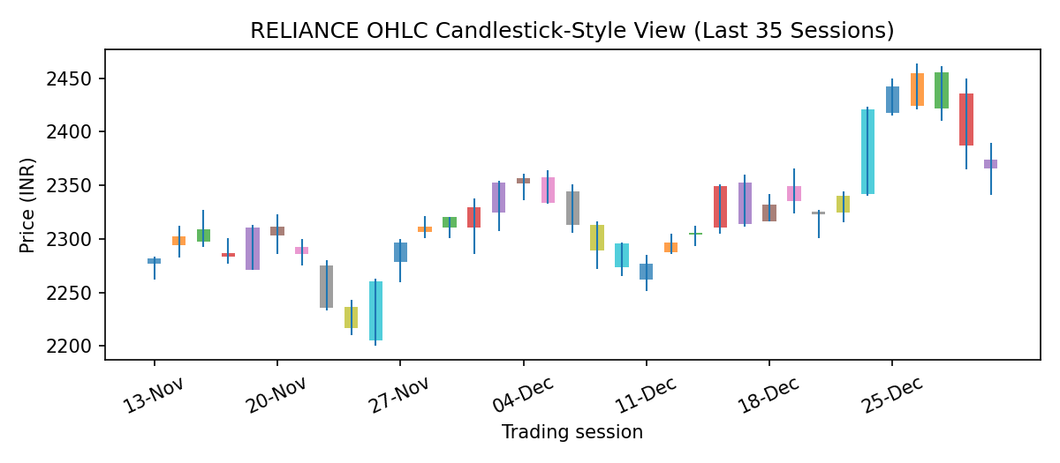
Figure 2.1: OHLC candlestick-style view for RELIANCE (illustrative last 35 sessions)
Interpretation: Each session displays the opening and closing prices as a body and the intraday high–low range as a wick. This view helps identify price gaps, trading ranges, and short-term momentum. The plotted data is synthetic.

2.2 Closing price with moving averages
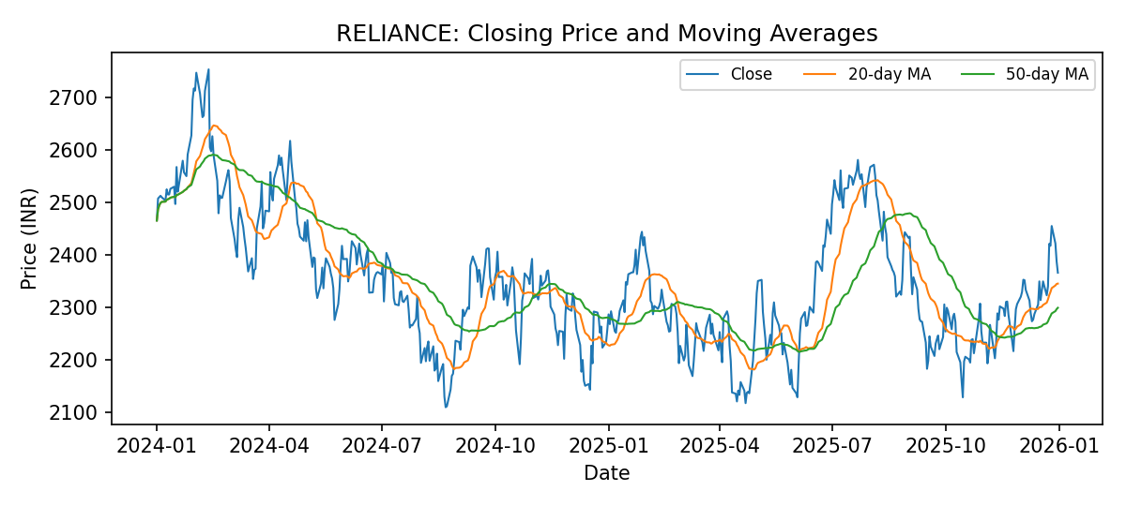
Figure 2.2: Closing price, 20-day moving average, and 50-day moving average
Interpretation: The 20-day moving average responds faster to recent price changes, while the 50-day average provides a smoother medium-term trend. A crossover can be used as a descriptive signal for further investigation, but it is not a guarantee of future returns.

2.3 Average daily trading volume by ticker
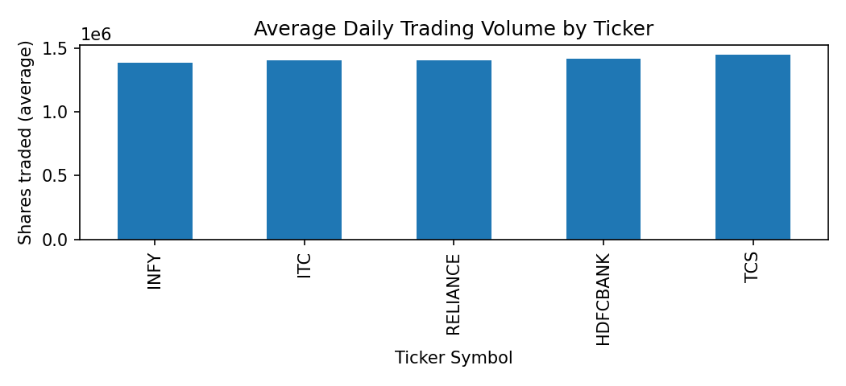
Figure 2.3: Average daily trading volume by ticker
Interpretation: The chart compares typical daily trading activity across the five sample equities. Higher volume can indicate greater trading activity, but volume alone does not establish liquidity, transaction cost, or investment quality.

2.4 Monthly equal-weight portfolio returns
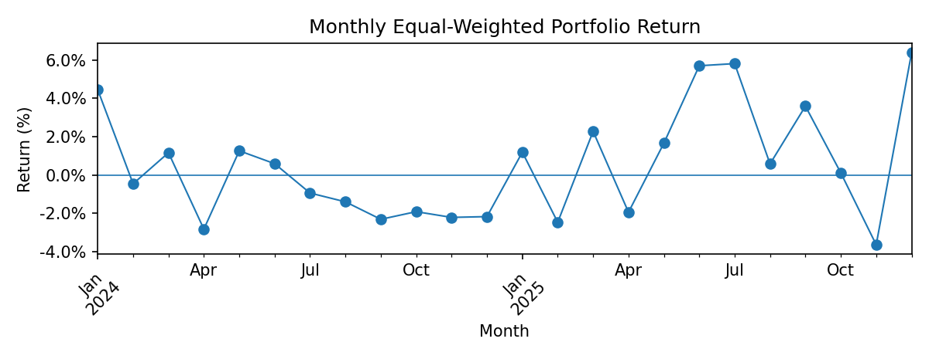
Figure 2.4: Monthly returns for the equal-weight illustrative portfolio
Interpretation: Monthly returns show how portfolio performance varies over time. Positive and negative months should be assessed alongside volatility and drawdown, rather than relying only on cumulative return.

2.5 Rolling volatility trends
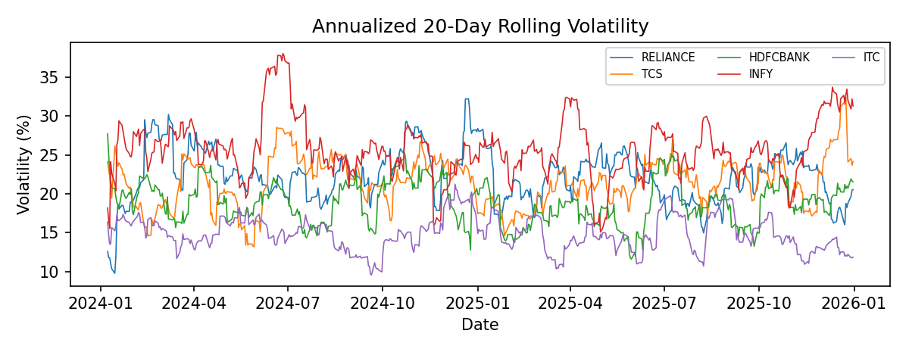
Figure 2.5: Annualized 20-day rolling volatility by ticker
Interpretation: Rolling volatility estimates how widely daily returns fluctuate over a moving window. A rise in volatility indicates greater recent variation in returns and can motivate closer risk monitoring.

2.6 Normalized price performance
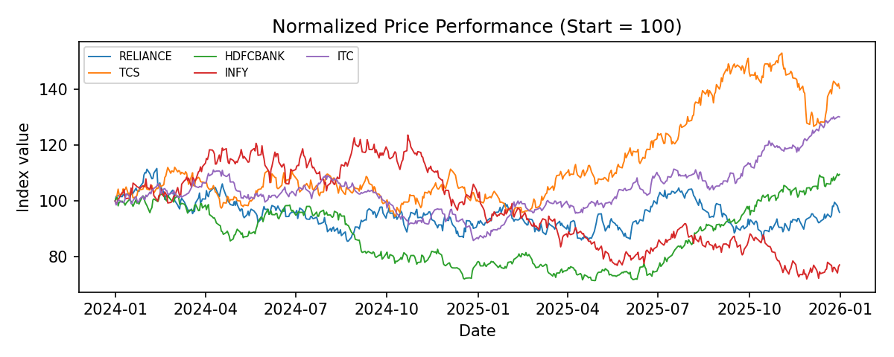
Figure 2.6: Normalized price performance with each ticker starting at index 100
Interpretation: Re-basing each closing-price series to 100 allows comparison of relative price movement despite different nominal share prices. The chart compares price performance only; it does not include dividends or transaction costs.

2.7 Daily-return correlation heatmap
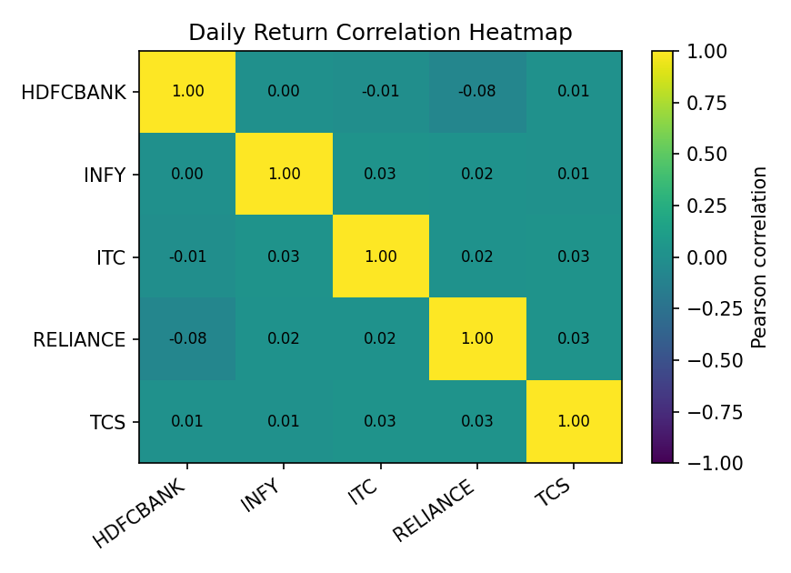
Figure 2.7: Pearson correlation heatmap of daily returns
Interpretation: Correlation values range from −1 to +1. Positive values indicate returns tend to move in the same direction, negative values indicate opposite movement, and values near zero indicate weaker linear co-movement. Correlation is not causation and can change during market stress.

2.8 Portfolio drawdown
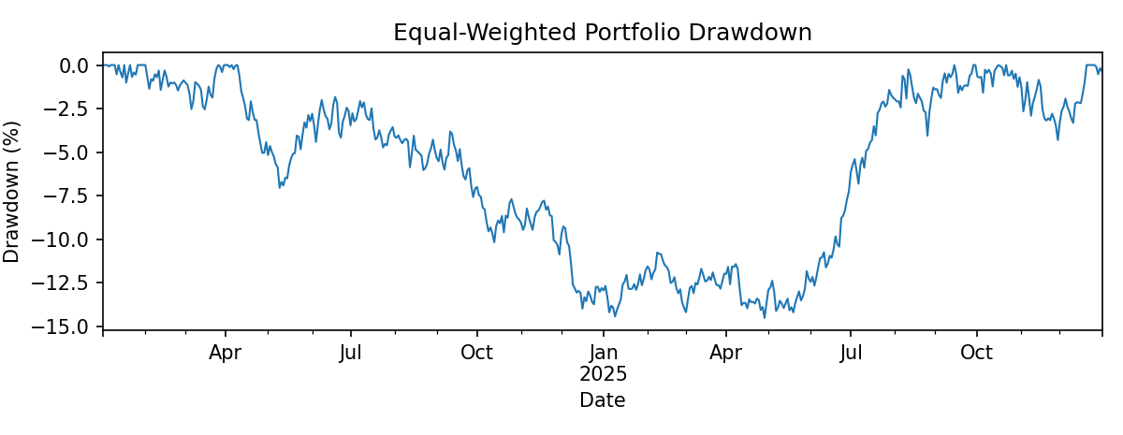
Figure 2.8: Drawdown of the equal-weight illustrative portfolio
Interpretation: Drawdown measures the decline from a previous cumulative-value peak. The deepest observed trough is the maximum drawdown, a downside-risk measure that complements volatility and return.

2.9 Quantitative summary
Using the generated sample and an equal-weight return series, the calculated total portfolio return is 12.25%, annualized volatility is 9.59%, Sharpe ratio is 0.63 under a zero risk-free-rate assumption, and maximum drawdown is -14.52%. Average daily volume across the ticker observations is approximately 1,414,302 shares. These are reproducible illustrative results, not verified historical market metrics.

Figure 3.1: Proposed Power BI financial dashboard (illustrative mockup).
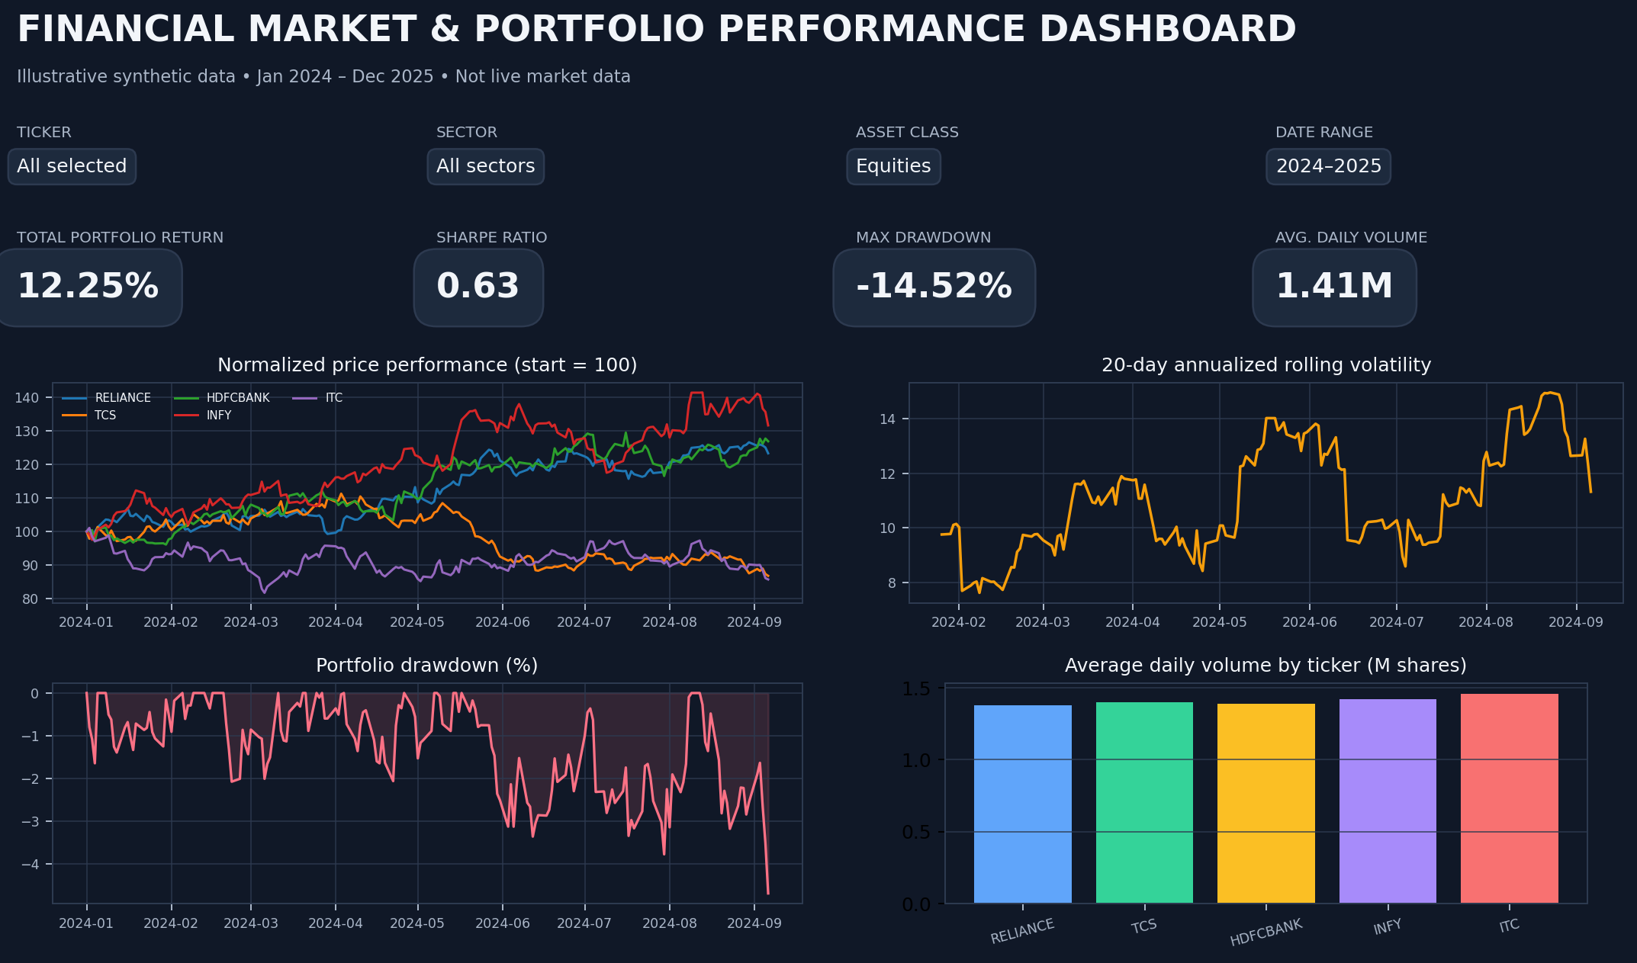
The mockup combines portfolio KPIs, normalized price trends, rolling volatility, drawdown, and trading volume. Build the final interactive version in Power BI.

3. Power BI Dashboard
Power BI can be used to create a one-page interactive “Financial Market & Portfolio Performance Dashboard” using Cleaned_Financial_Market_Data.csv. The layout should place the most important portfolio KPIs across the top, trend and risk charts in the central area, and slicers along the left or top edge.
Figure 3.1: Proposed Power BI dashboard layout (descriptive specification; build the visuals in Power BI using the cleaned dataset).

3.1 Filters and slicers
• Ticker Symbol: select one or more equities such as RELIANCE, TCS, HDFCBANK, INFY, and ITC.
• Sector: filter by the sector associated with each ticker.
• Date Range: select the analysis period.
• Year and Month: compare annual or monthly performance.

3.2 Financial KPI cards
• Total Portfolio Return: cumulative percentage change in portfolio value over the selected period.
• Sharpe Ratio: annualized excess return relative to volatility; the risk-free-rate assumption must be stated.
• Maximum Drawdown: largest peak-to-trough portfolio decline.
• Annualized Volatility: standard deviation of daily portfolio returns scaled by √252.
• Average Daily Volume: average shares traded per ticker or across the selected set, with aggregation clearly labelled.

3.3 Charts and interactions
• Price trend with 20-day and 50-day moving averages.
• OHLC/candlestick visual for selected ticker and date range.
• Portfolio return and cumulative growth line charts.
• Rolling volatility and drawdown charts.
• Asset-return correlation heatmap.
• Average daily volume by ticker and sector.

3.4 Dashboard insights and validation
The dashboard should allow users to identify which selected assets contribute to portfolio movement, when volatility increases, and how strongly assets co-move. All KPI cards and charts should respond consistently to the ticker, sector, and date filters. Verify that portfolio return is calculated from a clearly defined weighting method and that volume is not accidentally summed across mismatched date ranges.

Figure 4.1: Proposed Tableau financial dashboard (illustrative mockup).
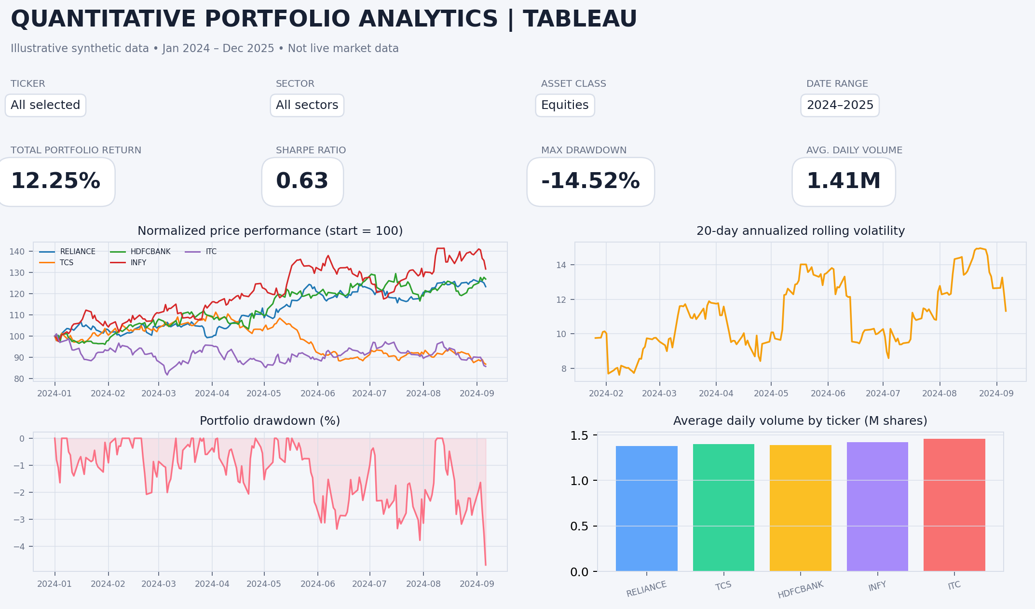
The companion layout uses the same financial KPIs and filters for consistent cross-platform interpretation. Build the final interactive version in Tableau.

4. Tableau Dashboard
Tableau can present a companion dashboard titled “Quantitative Financial Market & Portfolio Performance Analytics” using the same cleaned dataset. A recommended layout places KPI tiles across the top, a price-and-moving-average chart in the upper centre, return and risk charts below, and filters in a left-side panel.

4.1 Filters
• Ticker Symbol and Sector filters for selecting individual assets or groups.
• Date Range slider for selecting the analysis window.
• Year and Month filters for time-based comparisons.

4.2 KPI tiles
• Total Portfolio Return (%).
• Sharpe Ratio (annualized, with risk-free-rate assumption documented).
• Maximum Drawdown (%).
• Annualized Volatility (%).
• Average Daily Volume (shares).

4.3 Recommended visualizations
• Price movement and moving-average crossover chart.
• Candlestick/OHLC chart for the selected ticker.
• Monthly portfolio-return trend.
• Rolling volatility and drawdown over time.
• Daily-return correlation heatmap.
• Average daily volume by ticker and sector.

4.4 Interpretation and dashboard consistency
The Tableau dashboard should make it possible to compare performance and risk across assets without mixing price levels with percentage returns. Use consistent date filters, portfolio weighting assumptions, annualization conventions, and missing-data rules across all visuals. Do not display synthetic sample KPIs as live market values.

5. Conclusion
This project demonstrates a financial analytics workflow from raw market observations to cleaned data, quantitative indicators, visual analysis, and interactive dashboard design. Python supports data validation and feature engineering, while Power BI and Tableau provide accessible interfaces for filtering and comparing portfolio performance. Daily returns, moving averages, volatility, correlation, Sharpe ratio, and maximum drawdown provide complementary views of market behaviour. The illustrative results show how these measures can be calculated, but actual investment decisions require verified market data, appropriate portfolio assumptions, and independent risk assessment.

Appendix A: Core Python workflow
# Run after loading and cleaning the financial CSV
df = df.sort_values(["Ticker", "Date"])
df["Daily_Return"] = df.groupby("Ticker")["Close"].pct_change()
df["MA_20"] = df.groupby("Ticker")["Close"].transform(
lambda x: x.rolling(20, min_periods=20).mean())
df["MA_50"] = df.groupby("Ticker")["Close"].transform(
lambda x: x.rolling(50, min_periods=50).mean())
df["Volatility_20D"] = df.groupby("Ticker")["Daily_Return"].transform(
lambda x: x.rolling(20, min_periods=20).std() * np.sqrt(252))
df.to_csv("Cleaned_Financial_Market_Data.csv", index=False)

Appendix B: Data and interpretation note
The included charts and reported summary statistics are generated from a reproducible synthetic dataset for academic demonstration. For submission using real observations, replace the illustrative CSV with a documented, properly licensed market-data source; record the source, retrieval date, exchange calendar, corporate-action adjustments, and any missing-data decisions; then regenerate the charts and KPI values.

